Decorator Pattern

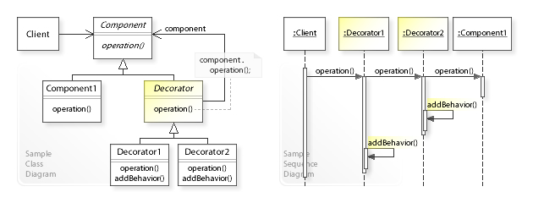

In [object-oriented programming](https://en.wikipedia.org/wiki/Object-oriented_programming), the decorator pattern is a [design pattern](https://en.wikipedia.org/wiki/Design_pattern_(computer_science)) that allows behavior to be added to an individual [object](https://en.wikipedia.org/wiki/Object_(computer_science)), dynamically, without affecting the behavior of other objects from the same [class](https://en.wikipedia.org/wiki/Class_(computer_science)).